- Log into portal
- Side bar click on Appointments
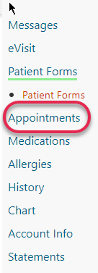

- Click on Schedule Appointment
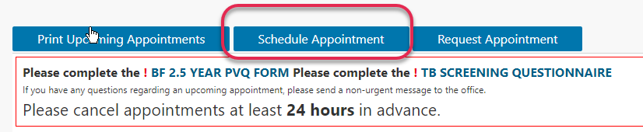

- Click on drop down and select your location
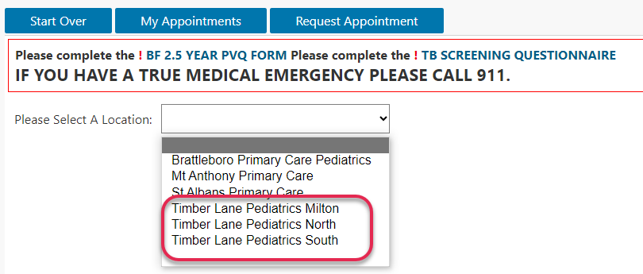

- If your child has not been “scheduled” with the nurse at any of the location selected you will receive the following message. You will need to call to schedule your appointment.
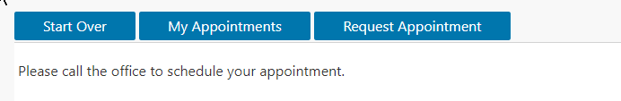

- If your child has been “scheduled” with the nurse you will see the following: Click on the drop down to select the appointment type.
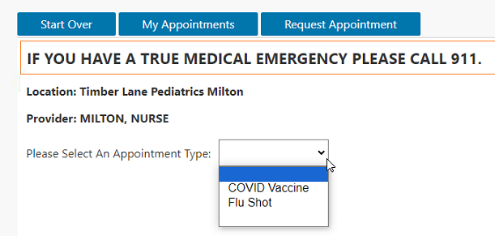
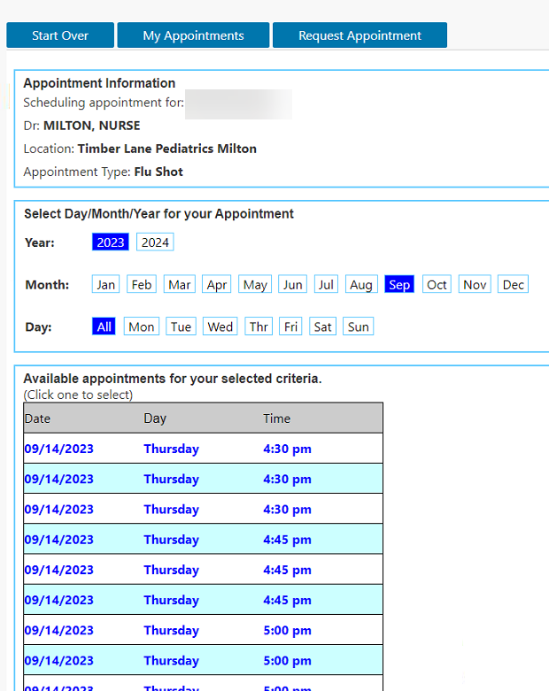
- Select the desired time/date

- Click on Book My appointment
